CS 255 System Design Document

UML Diagrams

UML Use Case Diagram
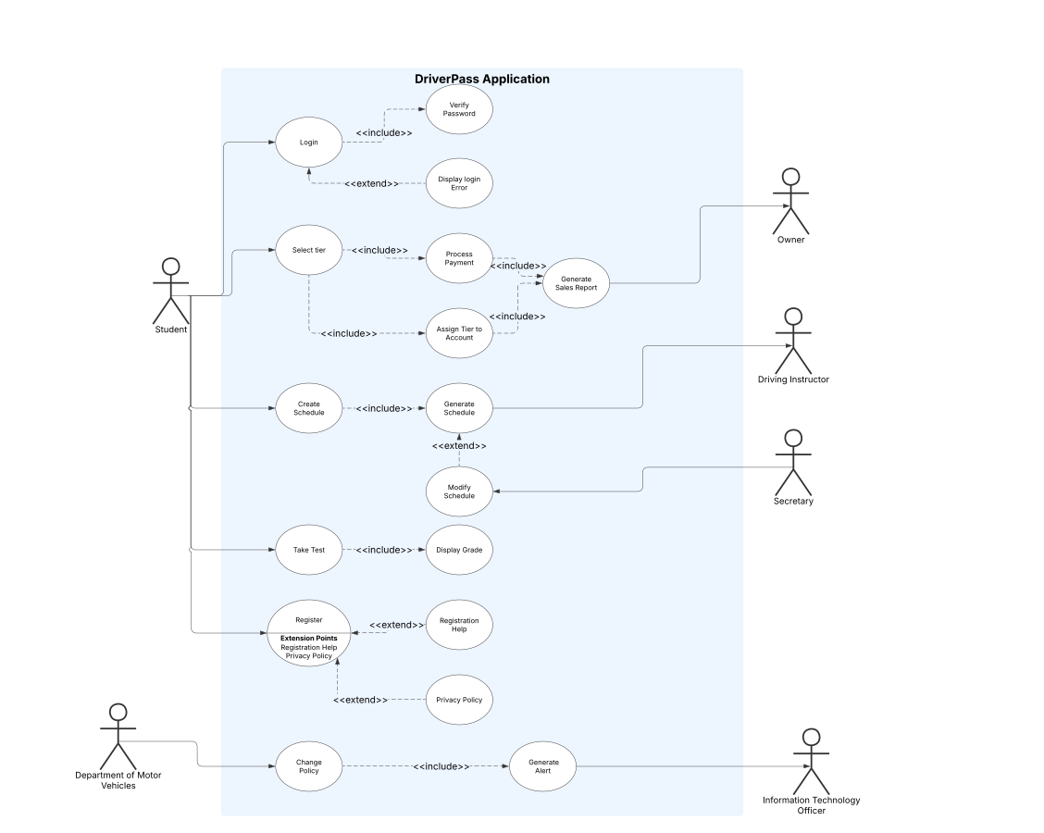

UML Activity Diagrams
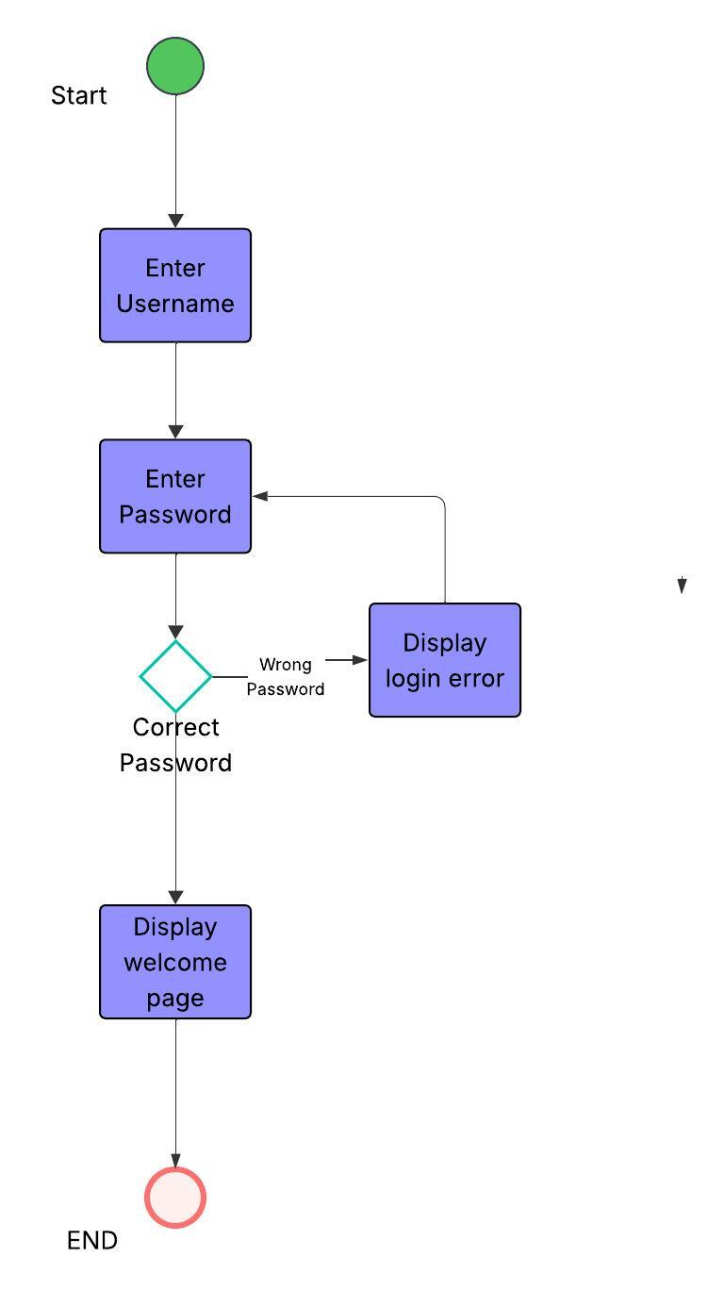

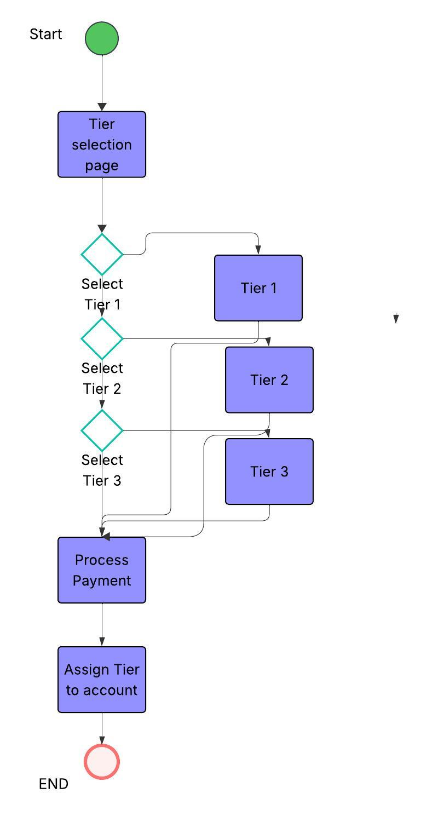

UML Sequence Diagram
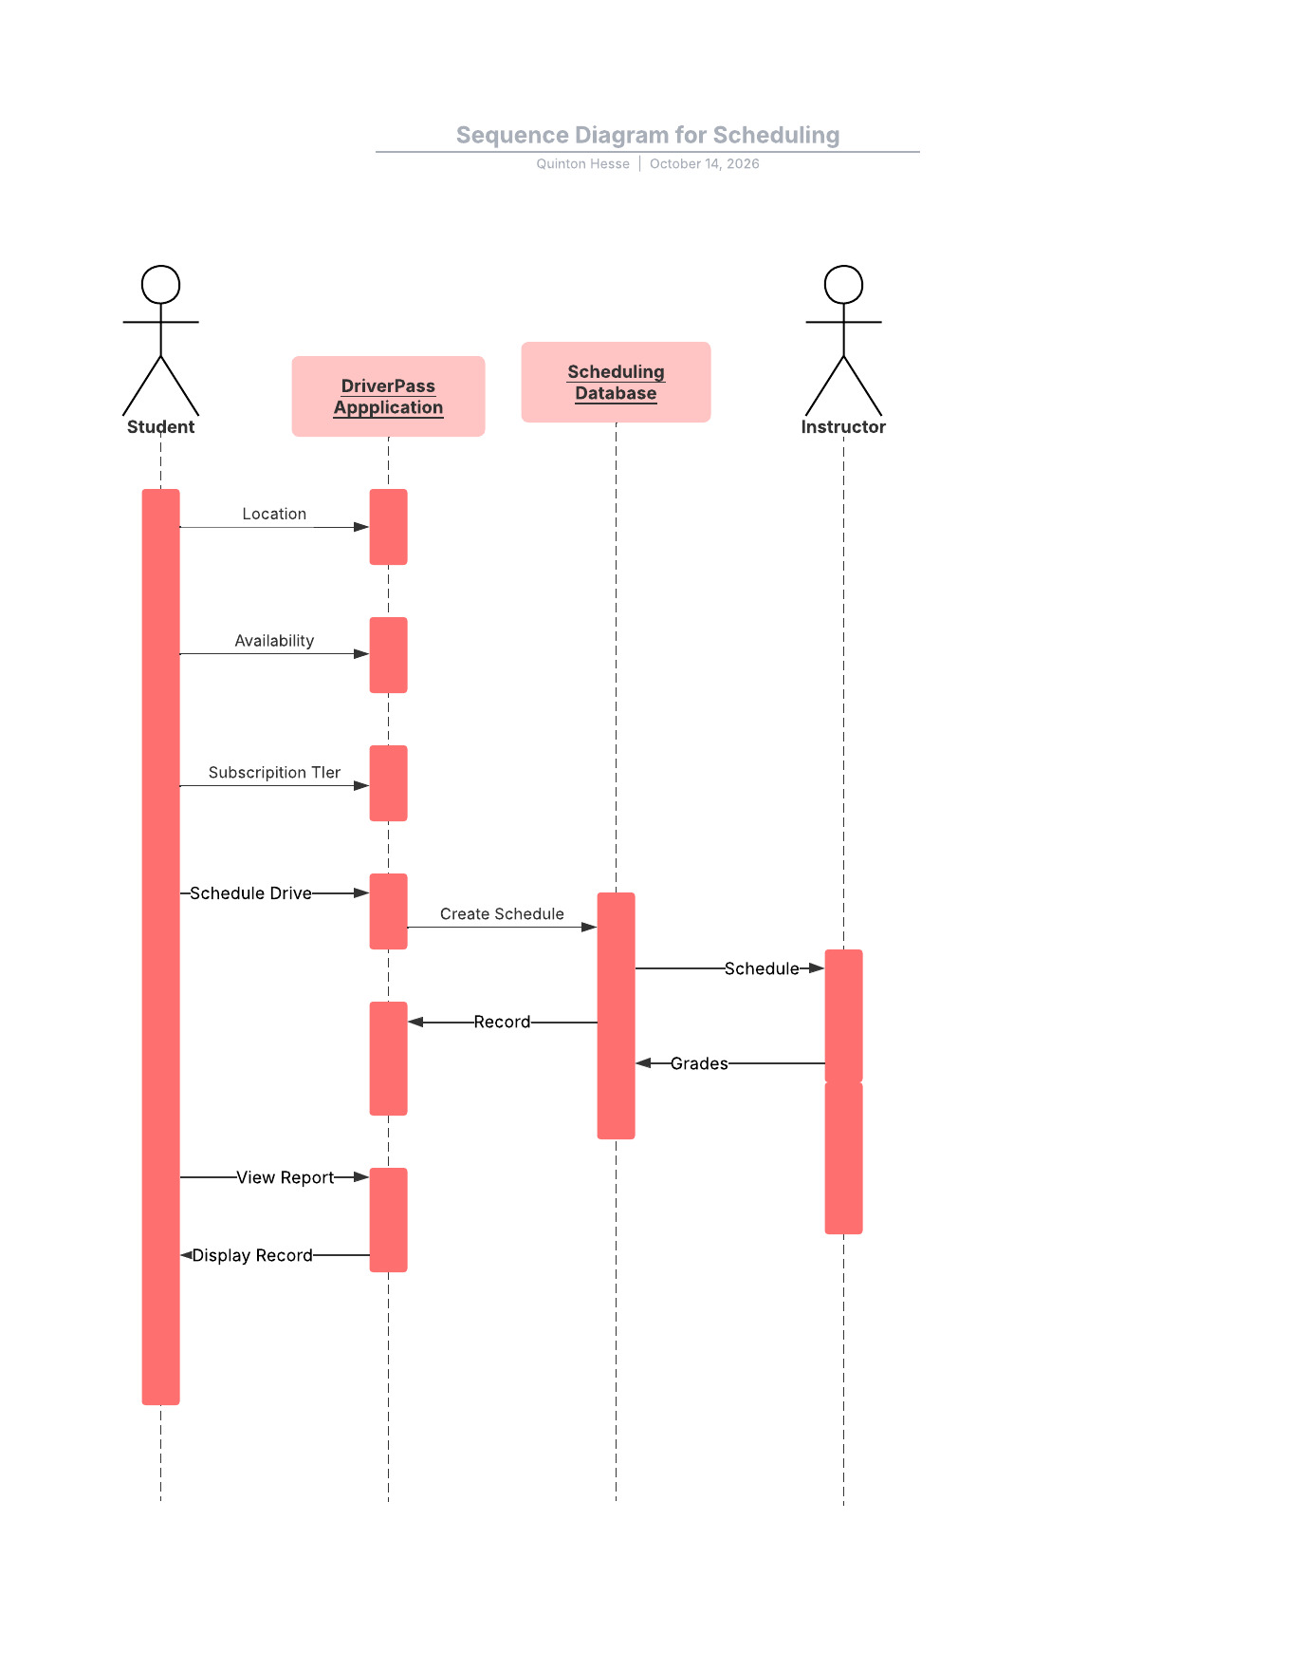

UML Class Diagram
[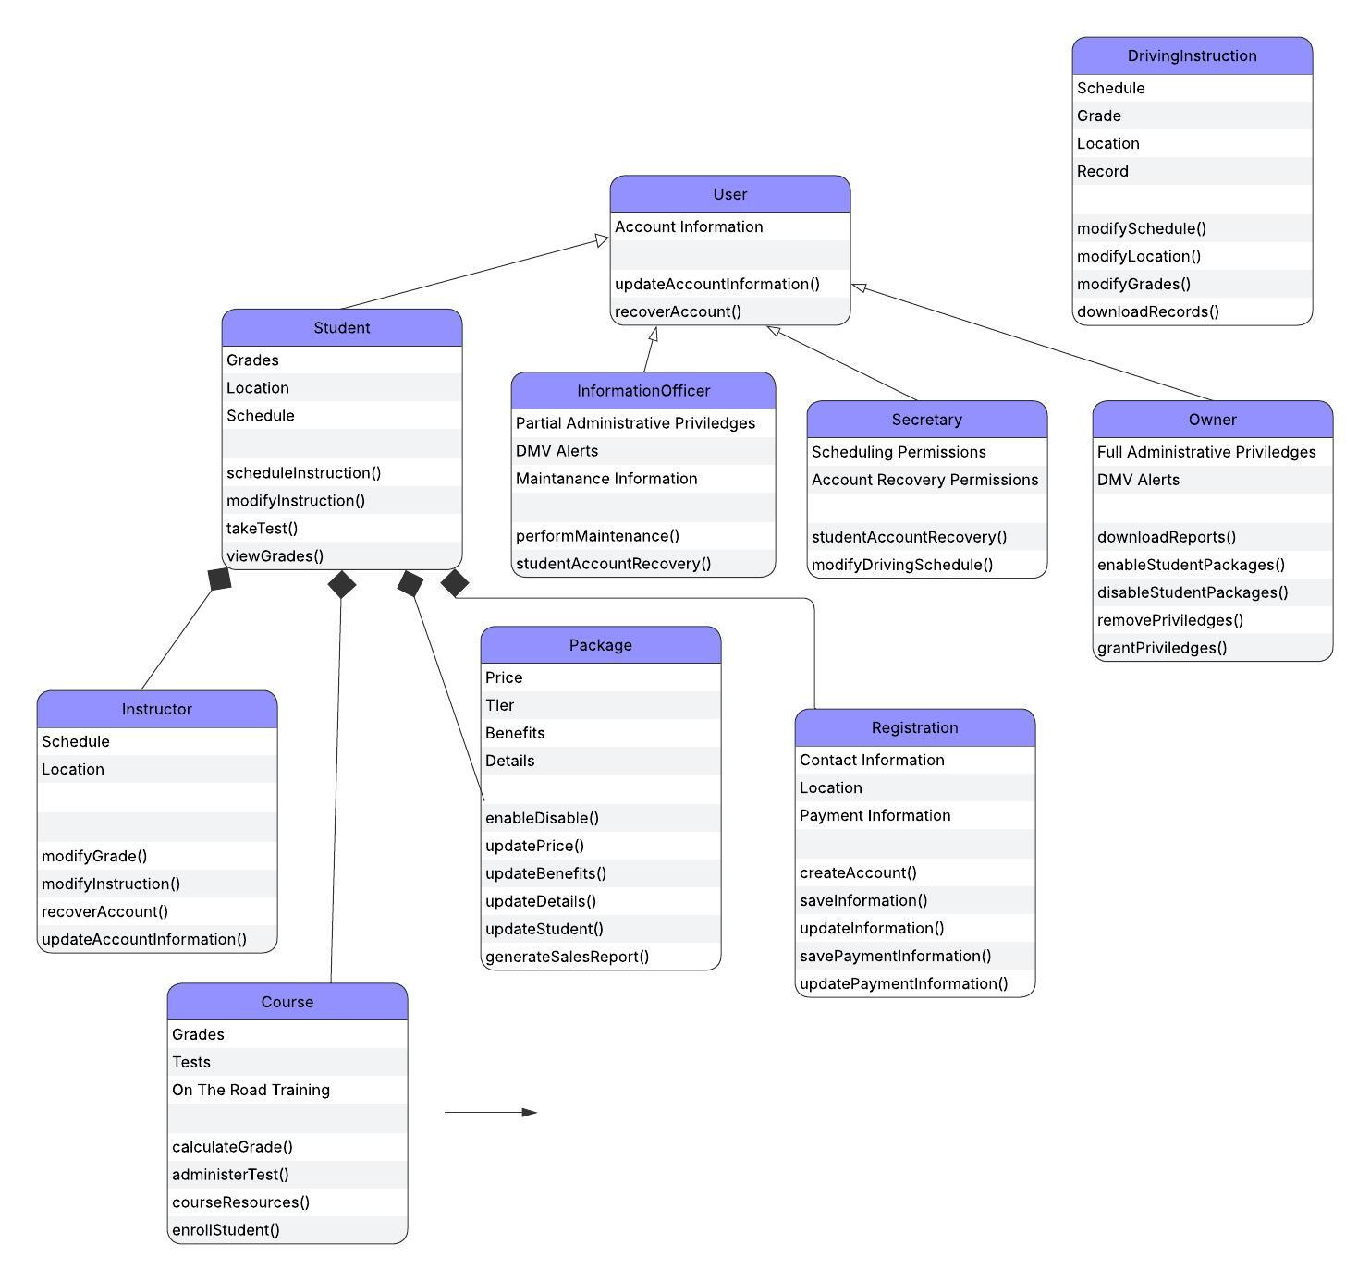

Technical Requirements
[Based on the diagrams you have created, describe the technical requirements of your system. These requirements should address the required hardware, software, tools, and infrastructure necessary for your system design.]

Security
- User authentication
- Payment information encryption
- User privileges

Cloud based Infrastructure
- User database
- User tier database
- Schedule database
- Application service

Automated Workflows
- Department of motor vehicle alerts
- Sales reports
- Schedule generation
- Administered online tests

Ease of access
- Schedule modification
- online registration
- Online driving records
- Online grades
- On the fly package management

